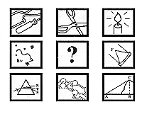

THE CREATIVE SCIENCE CENTRE
www.creative-science.org.uk

Notes by Dr Jonathan Hare

Making your own phonograph is a difficult thing to do, although of course that's no reason for not having a go at making one yourself. Its also difficult to describe in words how to do it! I hope the pictures helps you to follow the description (see web site etc).

I was extremely lucky to get my Rough Science phonograph working. In fact no one at the time thought it would work and knowing the difficulties involved I didn't expect to get much done in just 3 days (1 1/2 days to make it and only 1 1/2 day to play with it).

On the first proper test I asked the cameraman and soundman if they wouldn't mind being kind and recording it ... and it worked! It was the only time I got it to work, tried for hours but I never got it to work again ... but then time ran out and we had to tackle another set of RS challenges.

Here is what I can remember about making the Rough Science phonograph. Sorry for constantly changing the units from cm to inches.

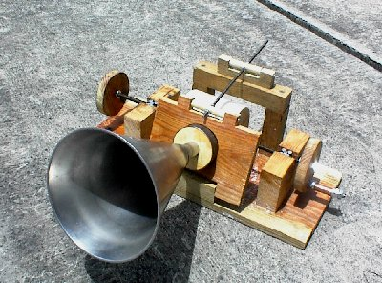

Firstly a solid wooden base about 50 x 30cm was cut from a piece of 1/2" plywood. Next wooden blocks about 15cm long were cut from a piece of 4" x 2" wooden timber. These blocks were secured to the base using 2 or 3 large (6cm) wood screws. The blocks were situated near to each end of the wooden base about 5cm from the edge and midway along the bases sides. Before fitting I cut a slot in the top of both wooden blocks big enough to take a M10 nut (see below).

A 60cm or so 10M (10mm) studding / thread was used as the support / drive mechanism for the phonographs drum (recording surface). Two 12cm diameter circles were cut from the plywood used for the base. These were cut and (the center) marked as accurately as possible. These two circles were drilled (10mm) and passed onto the thread and secured in place using washers and a nut either side. The two circles were spaced about 15cm apart but not midway along the thread but to the right side say 15cm from the end. Nuts were then added to each end of the thread and these were used as our bearings to allow the studing to rotate (and move along ... but more on this later).

These two nuts were moved along the thread till they lined up to the position of the wooden blocks and fixed into their slot cuts using screws to hold them in place (so they did not rotate).

Another circle was cut out about 10cm diameter and used as the handle for the phonograph. The center was drilled and fitted to the thread and a short piece of thread was fixed near to the circumference to act as a handle, see pictures.
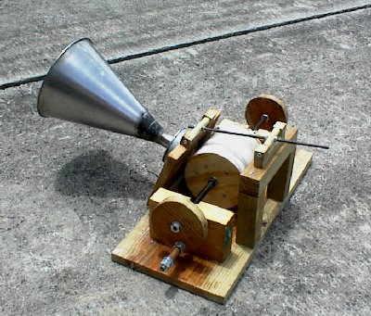

3 or 4 wooden bars each about 15cm x 5cm x 1/2" thick were then screwed between the circles to make a thing that looked a bit like a mini water wheel. String was then wound around the bars to make a surface on which to build up a surface of wax. Enough string was added till it came a cm or so to the the edge / circumference of the wooden side circles.

Early phonographs used wax to record the sound vibrations and that's what we did here. Later, better quality phonographs used metal cylinders instead and these gave much improved results but you really need a Lathe to make them. I tried using a thin aluminium foil layer over the wax but it just kept on getting torn. I couldn't get it to work.

When the handle was turned the nut 'bearings' (that the thread is turning through) which are fixed into the wooden blocks make the thread and all the apparatus fixed to it move sideways (the amount moved per turn being dependent on the pitch of the screw thread).

Making the blank wax cylinder
We heated up some candle wax (we used a bees wax candle wax mixture because it what we found lying around) in an old saucepan and poured it over the string turning the handle so as to make it as even as possible. I tried to make sure that there were no gaps, holes or air bubbles.

We added more and more until the layer was well above the wooden side circles. It was then left for 10-20 mins to cool off. We now had a rather lumpy wax cylinder between the wooden circles.

We then attached another wooden block a cm or so from the side of the wax cylinder in such a way that when you turn the handle the wax cylinder will travel past the block. We unwound the thread so that the wax cylinder was to the left of the block. Next a new (sharp) metal blade was fixed to the block (or simply hold it securely to the block by hand).

When the handle was turned quite fast and at an even speed the wax cylinder goes past pushing the blade into the wax. If you hold it firm shavings of wax come off.

The first time you do this much of the unevenness of the wax will be removed and you will have a more perfect cylinder of wax. Then removed the blade and turned the thread in the other direction to take it back to the start. Then we shaved off some more of the wax but far less this time. After another 2 or 3 repeats (with the blade taking off less wax each time) of this process an extremely smooth and very perfect cylinder of wax is produced.

Adding the horn and stylus
Now we had a blank wax cylinder which we used to record the sound onto ... and then play it back. A large horn made out of a large funnel was attached to another circle of wood which fitted into the top (open end) of a small (tuna) can about 7cm in diameter and about 3cm high. When you talk into the funnel / horn you can feel that the back side of the can vibrates nicely.

We then removed the horn / wooden circle and made a small hole in the center of the can and glued in a drawing pin so that the sharp pin faced out from the bottom of the can. This was our stylus which will make the grove and record the sound into the wax. Let us call the horn, circle, can and drawing pin the 'recording device'.

We needed to make a very firm bracket for this recording device because it was quite heavy and cumbersome but needs to be held very rigidly in place. We used a piece of wood on a hinge and another small piece of thread to act as a support to lock the whole thing once it was in its correct place (see picture).

The stylus made from the drawing pin needed to cut into the wax to a depth of about 1/2 mm and it should only move in and out due to the can vibrations rather than movement of the horn for example. This is perhaps the hardest part of the whole thing as this needs to be done as accurately and as best as we can. Its where the phonograph can fail.

When we were ready to start we pulled the recording device away from the wax cylinder (by unlocking the thread support and using the hinge) and turned the handle so that the wax is as far to the left hand side as possible.

Recording
We lowered the pin / stylus so that it just touched the wax (it dipped in to it to about a depth of 1/2mm or so). The handle was then turned quite fast and speedy. The pin cut a spiral into the wax. When you shout into the horn the vibrations travel down the horn to the tin can. The tin can surface will vibrate moving the drawing pin in and out at the same time.

The spiral will thus slightly change in width as it cuts its way through the wax making a physical record of the vibrations (sound) that was caused by shouting into the horn - in other words we should have recorded a sound!

As the drawing pin movements is very small we needed to try and make the sounds as large as we could which is why we needed to shout into the horn!

Replaying the recording
When we got to the end, perhaps after only 5-10 seconds, we very carefully removed the recording device (using the hinge) and rewound the cylinder back to the start.

We now use the recording device as a playback device. We put back the stylus / pin into the start of the grove. You can then re-lock it in place in the start of the groove or have it rust resting in the groove by added just a little weight so that the needle tends to fall into the grove rather than fall out. This was perhaps the very most difficult part of the whole phonograph procedure as too much pressure would wipe the recording (assuming there is one) and too little pressure will mean the pin will not feel the grove and no sound will be produced.

Before you do anything further set-up a tape recorder near to the phonograph to record your first phonograph test (it might work first time and never again, as it did with me!). You don't want to miss anything.

With the pin in the start of the groove turn the handle the same way and speed as you did when you made the recording and listen to the horn. If you are lucky you will hear a very distorted copy of what you sounded like when you shouted in the horn !

In my recording a shouted a bit and ended with a loud 'BOW WOW' or something like that. On playback I only heard a lot of noise then a faint 'dow dow' - it was something though!

If you heard something - WOW you did really well! if not don't worry it took Edison 1000 of hours to get it to work properly - so keep on trying!

To make another recording you need to shave down the wax surface again using the sharp blade - you cant make use of an old grove. Repeat all the processes above but try positioning the drawing pin so that it pushes a little deeper / or perhaps a little less deeper into the wax when it cuts its spiral.

GOOD LUCK!
DONT GIVE UP!!

