A Geodesic Dome
NOTE: A (black tape) = 35 x long sticks, B = 30 x shorter sticks (A/B ~ 1.18, e.g. 60 and 66 cm)
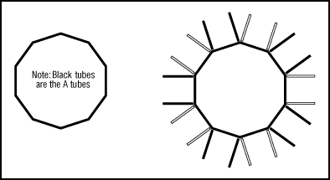
1. Arrange 10 long (A) sticks in a circle (long ones have got black tape around the middle)
2. Join them together at the ends using one of the 26 pipe connections.
3. Lay alternating pairs of A’s and B’s radiating out from the central circle.
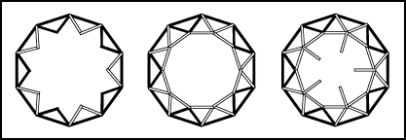
4. Pick up two of the A’s (long) and form a triangle with them and one of the A’s from the circle. Join them together firmly.
5. Do the same thing with the rest of the stick pairs. You should end up with a circle of triangles poking into the air. Tall triangles should alternate with short triangles.
6. Connect the triangles by joining a row of B’s (small) across the top.
7. Every point where four B’s come together, join on another B (short) pointing straight up.
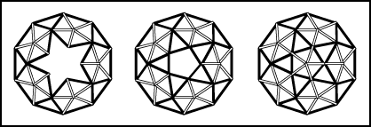
8. Brace the B’s by using two A’s (long), one attached to each adjacent joint.
9. Connect the tubes by joining a row of A’s (long) across the top.
10. Finish the dome by adding the last five B’s (short). These tubes come from the five joints and meet in the middle to form the top pentagon.

For more information see The Creative Science web site:
http://www.creative-science.org.uk

