Internet Workshops for Schools and Colleges (e-w/s)

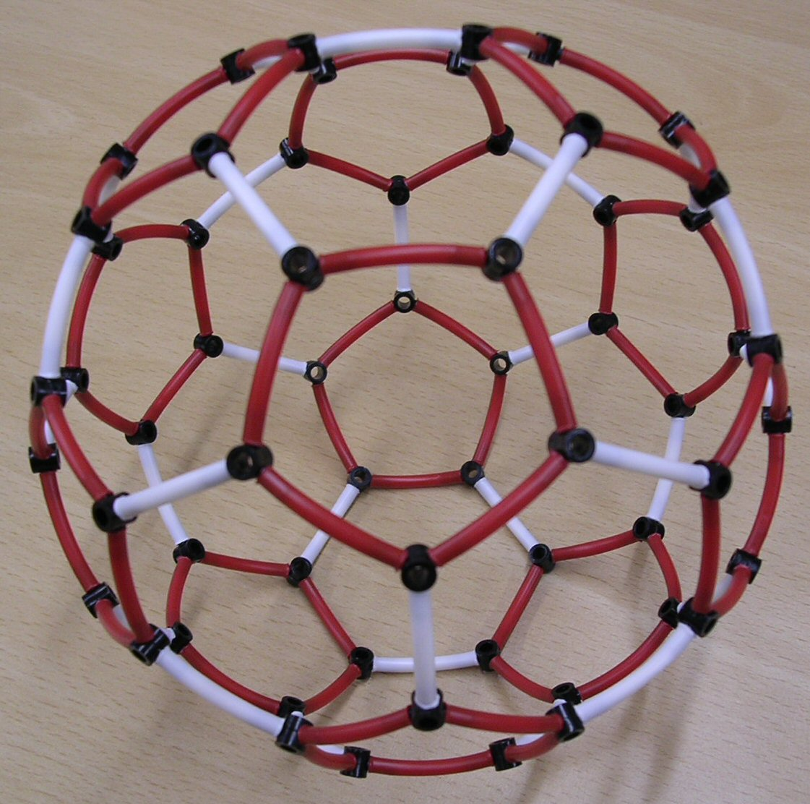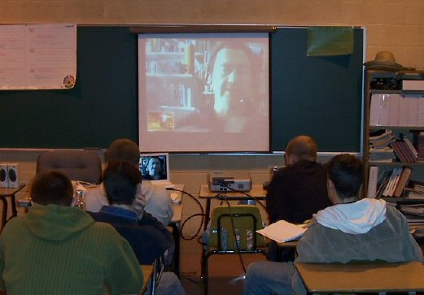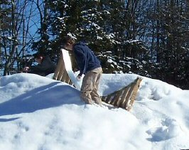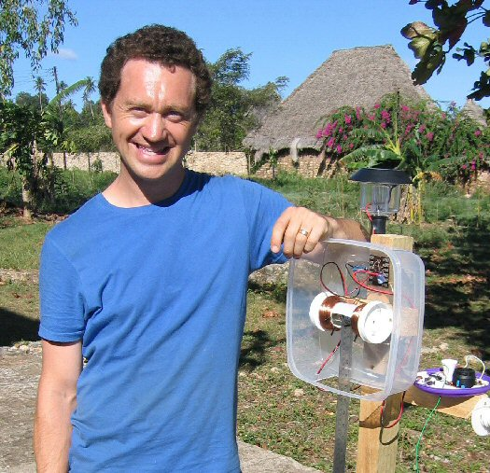

Dr Jonathan Hare provides guidance, inspiration and in some cases equipment for a range of science workshops (e-w/s) via the internet. Using free software such as Skype, MSN messenger or ooVoo and standard web cameras and microphones two-way workshops can be run anywhere in the world where there are broadband connections. The e-w/s provide schools and colleges with access to a professional scientist straight into the classroom, either for a full workshop or for Q & A sessions as well as ‘ask an expert’ type activities.

Who are they for?
These workshops will suit schools and college as well as home educators.

What do you need to do?
You need to install the video conferencing software (free download and use) and have a web camera and microphone set up (this can be bought very cheaply now). If you are a school you might need to set up your firewall to allow the VC software to communicate over your internet. A data projector in the class is preferred to a small screen to ensure a good visual contact between pupils and scientist.

Workshops and Activities offered
These include C60, Buckminsterfullerene, Voice on a Light Beam, Parabola, and Transistor workshops. There is written material associated with each activity as well as a number of mini films which JPH produced for the Vega Science Trust (an educational charity) - http://www.vega.org.uk - so that you can see key parts of the workshop again and again.

Costs
Each e-w/s will be charged on a workshop by workshop basis.

What people say about JPH’s e-w/s
“Video conferencing has really made a difference to me as a classroom teacher here in the United States ... it’s great to be able to show and talk about experiments in real time and get answers fast … in the future I can see using this technology a great deal to have on-line workshops where Jonathan can come into my classroom and share his areas of science and exploration.”
Russel Taylor, Bonny Eagle High School, Standish Maine (USA).

Dr Jonathan Hare – short Biography
Jonathan is a freelance science communicator. His PhD work led to a method of making the football molecule C60, Buckminsterfullerene. He has worked as a 'Time Lord' at the National Physical Laboratory working with atomic clocks as well as with British Gas developing a gas powered car. His TV work includes: BBC Rough Science and Hollywood Science as well as COAST. He is currently a visiting Research Fellow at Sussex University. He loves making things, juggling, hill walking, amateur radio and painting.

Notes:
- For JPH’s web site see: www.creative-science.org.uk
- Use web search engine for details of Skype, MSN messenger and ooVoo etc.
- For Vega mini films see: www.vega.org.uk/video/subseries/27

